Sitting Pretty

This exercise is designed to make you think about how much work an accountant must do to get QuickBooks ready for businesses to use. Imagine you are the accountant and you would ask the business owner “Do you want this account?” or “What are your business details?”

Mike Rowland runs a business called Sitting Pretty selling chairs – the Recliner and the Super Support. The business is located in a rented building in the local shopping centre. You interview Mike to find out the following information that you will input into QuickBooks.

Click on the QuickBooks icon and it will open in the last business you were using. Click on File ‘New Company’. In ‘Getting Started’ click on “Start Interview”. (Change the colour of each sentence on this sheet as you do it so you don’t get lost.)

Enter the following Company Information for **Sitting Pretty** (Company name and Legal name)

* Tax ID 53004085616
* 756 Melbourne Street, Williamstown, 3016
* Phone 03 9835 2654 Fax 03 9835 3655 Email – sitting[pretty@bigpond.com.au](mailto:pretty@bigpond.com.au)

[www.sittingpretty.com.au](http://www.sittingpretty.com.au)

* Click on NEXT

Select your industry – Click on ‘**Product Sales / Retail**’, Next

Select the following options on each page and then click ‘Next’.

* Individual Tax Return
* My Financial Year starts in July
* Do not enter a password
* Create you company file – just click Next and Save Sitting Pretty to your Home Directory
* ‘Customising...’ click Next
* ‘What do you sell?’ – click ‘**Products and services’**
* ‘Do you track tax’ – Yes
* ‘Do you want to create Estimates’ – No
* ‘Tracking customer orders in QuickBooks’ - Yes
* Using Sales Receipts – Yes
* Using Statements – Yes
* Using Invoices – Yes
* Using Progress Invoices – No
* Managing Bills you owe – Yes
* Tracking inventory in QuickBooks - No
* Tracking Time – No
* Do you have employees – Yes
* Using account in QuickBooks – Next
* 'Select a date to start tracking your finances – Use today’s date or the first day of the quarter or month: click on the blue calendar and choose 01/(this month)/(this year). *Consider that as you complete this exercise all the transaction must be in one month and if the actual month ends, then you will have to enter every transaction as (last month). Think about this carefully and if it makes no sense, come and ask the teacher to explain.*
* Add your Bank account: Would you like to add an existing bank account? – Yes
* Enter your Bank account information – Venture Bank & Before 01/(this month)/(this year)
* Enter your Bank Statement information – 31/(last month)/(this year) and $3113.00 (Note: All the transactions that follow will be in this month, this year)
* Do you want to add another bank account – No, I’m done or will add more later.
* Reviewing income and expense account – Click Next
* ‘Congratulation!’ – Finished

Reduce the size of QuickBooks and these instructions so that you can have both on view on the screen.

Go to Home and Chart of Accounts and click on:

Cash at Bank1, Account, Delete, Are you sure? OK – repeat and delete the following accounts (work down the first column and then the second. Or scroll down the accounts and delete all these accounts then go onto the next page. Don’t forget to change the colour of each account as you delete them.) If some of your account could not be deleted, then leave them black and use the next lot of instructions to make them inactive.

* Cash at Bank 2
* Cash at Bank 3
* Amounts pay/rec holding company
* Amounts pay/rec related entity
* Debentures – listed company
* Debentures – unlisted company
* Debentures in unlisted company
* Debentures in listed company
* Deposits
* Deposits – building society
* Deposits on call
* Deposits on contracts
* Deposits with savings banks
* Equity in joint venture
* Equity in partnership
* Furniture and Fittings
  + Accum. PU depreciation 5
* Government Bonds
* Government securities
* Inv Raw Materials
* Inv work in progress
* Less prov impair receivables
* Loan from / Advance to holding
* Loans – secured
* Loans – unsecured
* Loans secured
* Loans to/ from directors
* Loans to / from employees
* Loans to / from related entities
* Loans unsecured
* Loans / Advance to subsidiaries
* NCA Equity in partnerships
* NCA Government securities
* NCA Loan from / to partners
* Options in listed companies
* Options in unlisted companies
* Petty cash imprest
* Prepayments
* Provision for unearned income
* Provision for unearned revenue
* Short term deposits
* Sundry Debtors
* Term Debtors
* Withholding tax paid
* Loans value pool (but you must delete the sub accounts first e.g. Less accumulated depreciation then go back and delete the original account e.g. Loans value pool)
  + Less accumulated depreciation
* Other Assets under leaves
  + Less accumulated amortisation
* Poverty improvement
  + Less accumulated depreciation
* STS general pool
  + Less accum impair loss
* STS long life pool
  + Less accum impair loss
* Amts from subsidiaries
* Debenture issue expenses
* Deferred Tax Assets
* *Derivative financial assets*
  + Derivative financial assets (this will delete but the one above will not)
* Formation Expenses
* Goodwill on Consolidation
* NCA Less accum amortisation
* NCA Less accumulated amort
* Accrued charges
* CL Lease liability
* CL Lease liability 2
* Employee entitlements
* Income in advance
* Provision for holiday pay
* Provision for LSL
* Provision for sick leave
* Balance sheet suspense
* Less unexpired hire purchase
* Less unexpired hire purchase 2
* Mortgage
* NCL Hire purchase liability
* NCL Hire purchase liability 2
* NCL Lease liability
* NCL Lease liability2
* NCL Loans – secured
* NCL Loans – unsecured
* NCL Mortgage 2
* Capital Stock
* Dividends Paid
* P/L Earned this year
* Associated companies
* Commissions received
* Consulting fees
* Discounts received
* Fair value gain
* Foreign currency exchanges
* Gain on revaluation investment
* Lease rentals
* Management fees
* Movement in net market values
* P/L Disposal Investment
* Professional fees
* Property Name(s)
* Re-imbursed Expenses
* Rebates
* Rental – Other
* Royalties
* Share of partnership profit
* Trust Distribution Received
* Tythes – Religious Organisation
* Manufacturing Costs
  + Aids to Manufacturing
  + Direct Wages
  + Expendable Stores
  + Freight and Cartage
  + Light and Power
  + Payroll Tax
  + Raw Materials
  + Repairs/Maintenance
  + Subcontractors
* Stock 2
  + Closing raw materials
  + Closing stock
  + Closing work in progress
  + Opening raw materials
  + Opening work in progress
* Administration costs
* Bad debts writing off
* Collection costs
* Commission paid
* Consultancy fees
* Contract work
* Data processing charges
* Debt collection
* Depreciation – building
* Depreciation – fittings
* Depreciation – leasehold land
* Depreciation – low value pool
* Depreciation – motor vehicles
* Depreciation – office furniture
* Depreciation – plant and equip.
* Depreciation – private use
* Depreciation – property improve.
* Depreciation – sts pool
* Discount allowed
* Doubtful debts
* Entertainment expenses
* Employee amenities
* Fees and permits
* Filing fees
* Fire brigade fees
* Flowers and decorations
* Fringe benefits tax
* Hire of plant and equipment
  + Employer liability (under Insurance)
  + General (under Insurance)
  + Professional indemnity (under Insurance)
  + Sickness and accident (under Insurance)
  + Workers compensation (under Insurance)
  + ATO (under Interest expense)
  + Finance charge (under Interest expense)
  + Hire purchase charge (under Interest expense)
  + Loans (under Interest expense)
  + Mortgage (under Interest expense)
* Laundry and dry cleaning
* Legal costs
* Less private use
* Licensing fees
* Motor vehicle expense – 2
  + Depreciation
  + Insurance and registration
  + Petrol and oil
  + Repairs
  + Tyres
* Motor vehicle expense – 3
  + Depreciation
  + Insurance and registration
  + Petrol and oil
  + Repairs
  + Tyres
* Newspapers
* Night patrol
* Packing materials
* Permits, licences, fees
* Petty cash
* Plans and permits
* Protective clothing
* Recorded music rental
* Registration fees
* Rental property expenses
  + Advertising
  + Agents Commission Fees
  + Bank charges
  + Borrowing expenses
  + Cleaning
  + Garden maintenance
  + Insurance
  + Interest paid
  + Land tax
  + Legal fees
  + Pest control
  + Rates – Council
  + Rates – Council 2
  + Repairs and Maintenance
  + Stationery, phone, postings
  + Sundry expenses
  + Travel expenses
* Salaries and wages
* Selling commissions
* Service charges
* Sign writing
* Staff training and welfare
* Stamp duty
* Stock taking expenses
* Storage fees
* Subscriptions
* Super contrib.– directors
* Super contrib.– employees
* Super contributions
* Telephone – less private use
* Tool replacements
* Wrapping and packing

Make the following accounts inactive (not deleted but out of sight) by clicking on Account > Making accounts Inactive:

* NCA Shares in assoc companies
* NCA Shares in unlisted company
* Prepaid borrowing expenses
* Shares – related corp.
* Shares in listed companies
* Shares in subsidiaries
* Stock on hand
* Undeposited Funds
* Investment property
* Leasehold land
  + Less accumulated depreciation (under Motor Vehicles)
* NCA Plant and Equipment
  + Less accumulated depreciation 3
* Plant and equipment under lease
* Derivative financial assets
* Development Expenditure
* Goodwill
* Less accumulated impair losses
* NCA Exploration Expenditure
* Patents and trademarks
* Shares – listed company
* Shares – related company
* Shares – unlisted company
* Shares in associated company
* Bills payable
* Hire purchase liability
* Less unexpired hire purchase 3
* Other creditors
* Payroll Liabilities
* Sundry creditors
* NCL Employee entitlements
* NCL Loans – bank
* NCL Provision for LSL
* Dividends received
* Government Subsidies
* Interest received
* Other revenue
* Private surcharge
* Recoveries
* Rent received
* Service fees
* Closing land held for resale
* Opening land held for resale
* Amortisation
* Direct investment expenses
* Leasing charges
* Estimates

‘Opening Bal. Equity’, then press Account. Select Edit Account. Type in **Capital** over ‘Opening Bal. Equity’, press ‘Save & Close.

Add a new account Drawings as an Equity by clicking on Account > New > Equity > Continue > type in Drawings > Safe and Close

Owner contributes Fixed Assets to the business

Go to Chart of Accounts and check if any of these assets already exist:

* Office furniture / equipment (and Original Cost)
* Delivery Van (and Original Cost)

Create a New Fixed Assets Account for those that don’t exist (Select Fixed Asset - major purchases) and Continue, type in the name of the account, Save and New, type in Original cost for both of the assets and make it a Subaccount of both of these Fixed Asset, Save and close once both accounts are complete.

Go to the Chart of Accounts and Double-click on Capital. The register will appear: enter the date 1/this month/this year.

In the Account column where it says ‘Payee’ field type in Mike Rowland (Add new, Other).

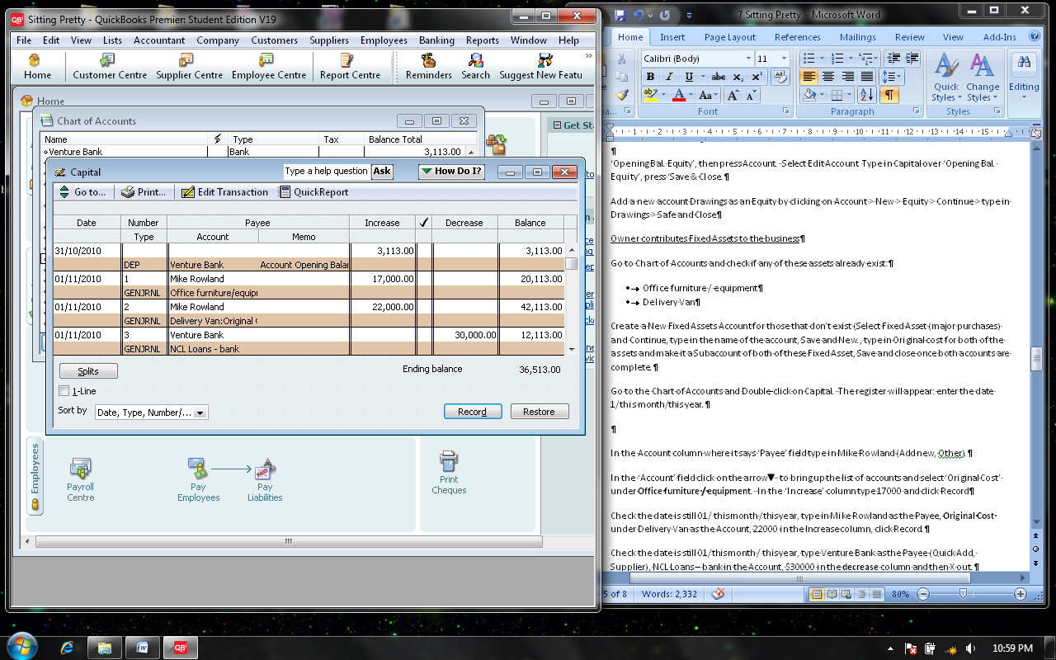

In the ‘Account’ field click on the arrow to bring up the list of accounts and select ‘Original Cost’ under **Office furniture / equipment**. In the ‘Increase’ column type 17000 and click Record down the bottom on the Register.

Check the date is still 01/ this month /this year, type in Mike Rowland as the Payee, **Original Cost** under Delivery Van as the Account, 22000 in the Increase column, click Record.

Check the date is still 01/this month / this year, type Venture Bank as the Payee (Quick Add, Supplier), NCL Loans – bank in the Account, $30000 in the **decrease** column and then X out.

Stock counted in the business at the end of last month

Recliner 10 in stock Cost price $1,000 each Total value $10,000 Selling price $2,500

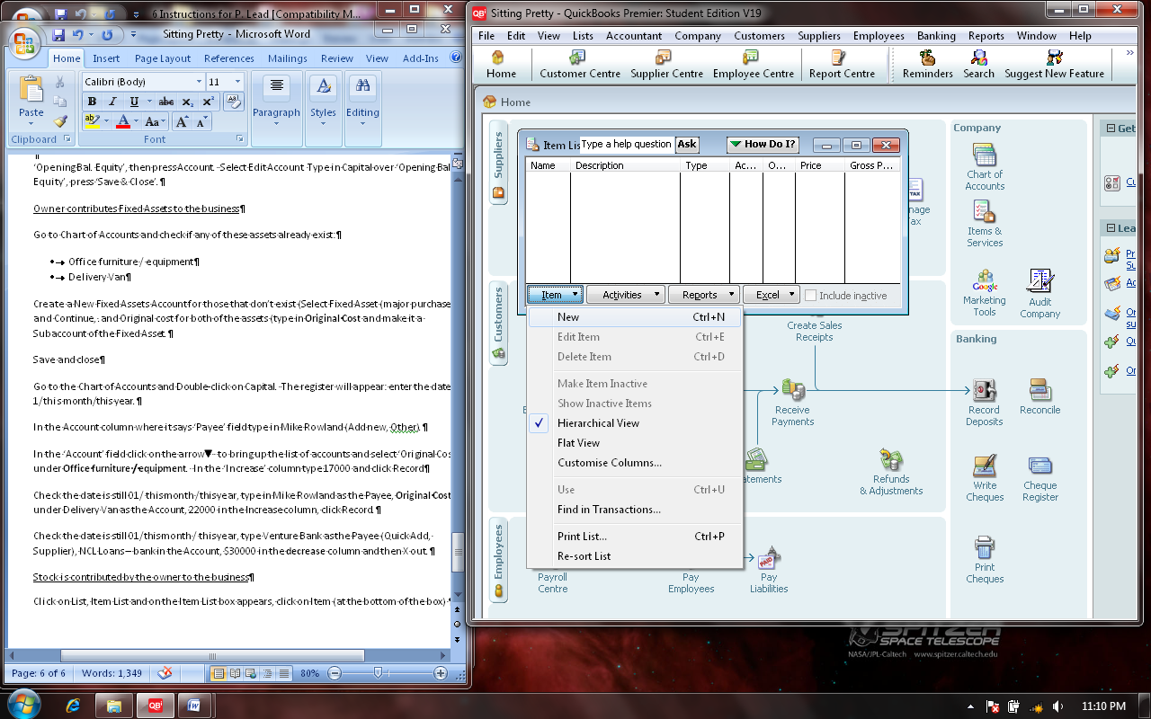Super Support 8 in stock Cost price $1,800 each Total value $14,400 Selling price $4,400

Click on List (on the bar at the top of the screen), Item List and on the Item List box appears, click on Item (at the bottom of the box).

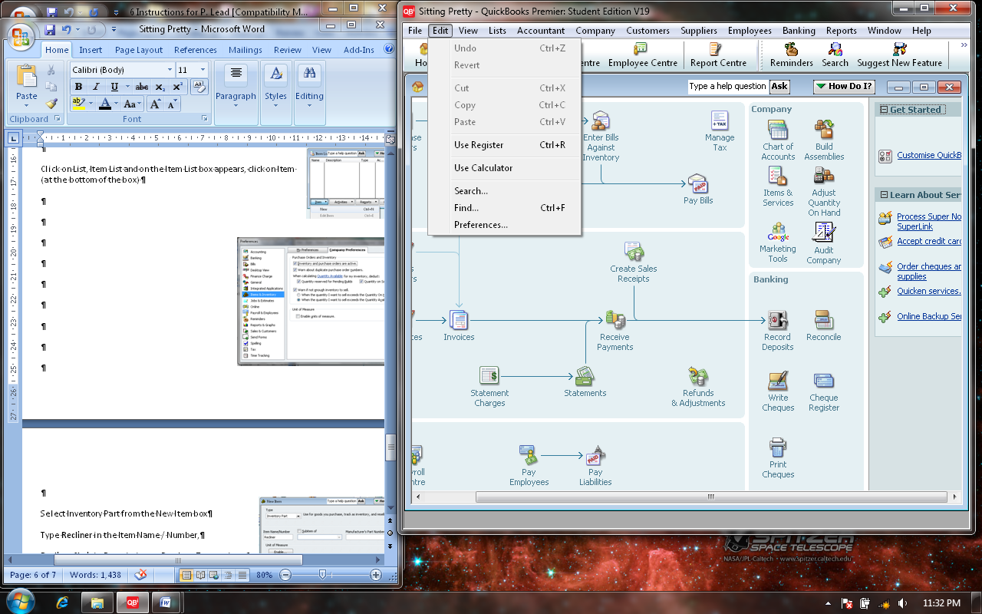If Inventory does **not** appear, you will need to check that the company preferences are correct. Go to **Edit**

and click on Preferences.

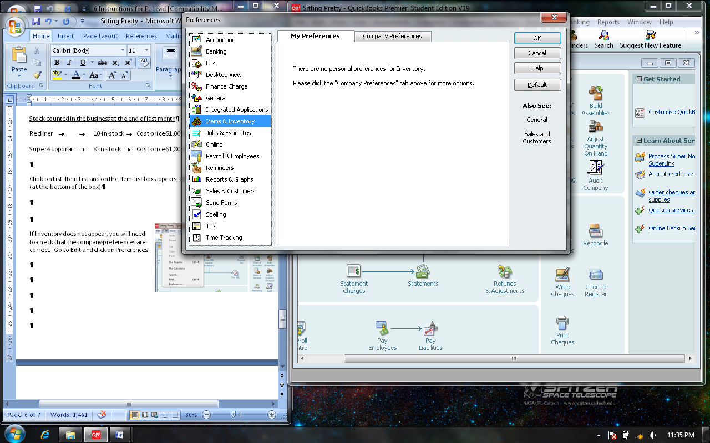Scroll down the list to **Items & Inventory**

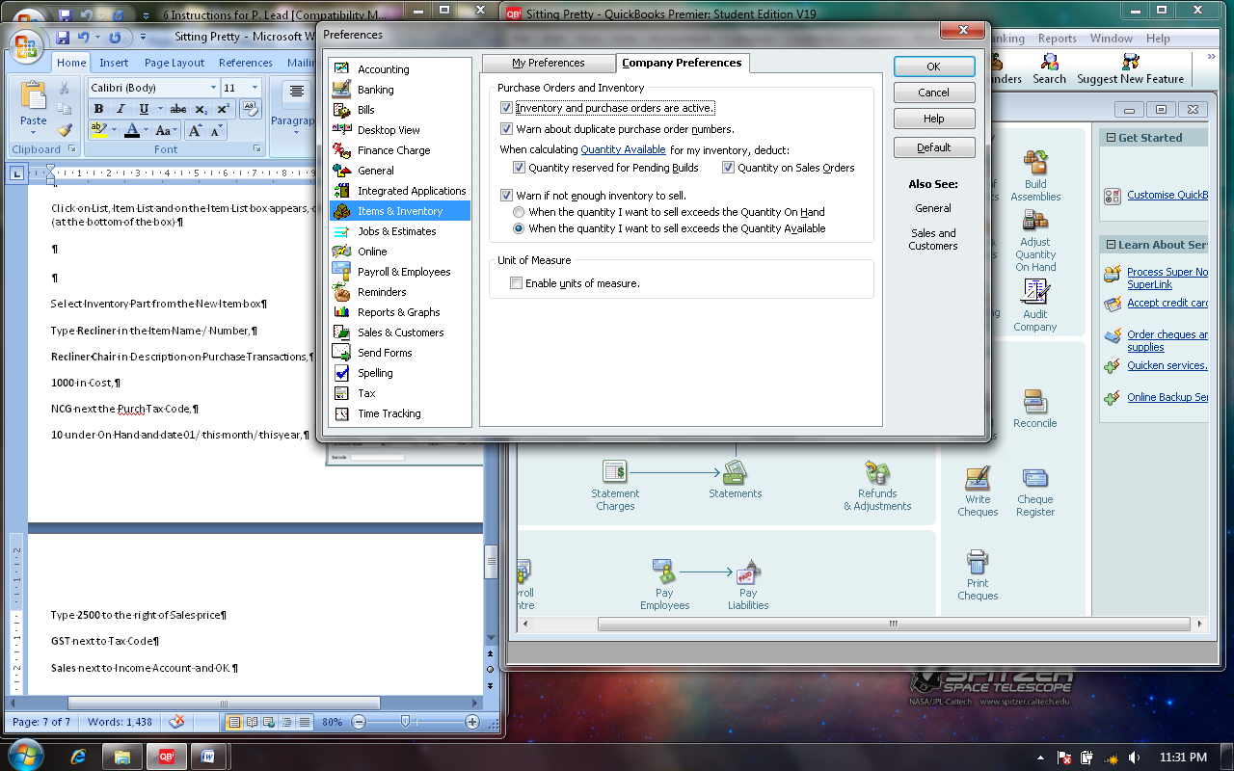Click on the **Company Preferences**

Click **Inventory and purchase orders are active** then OK

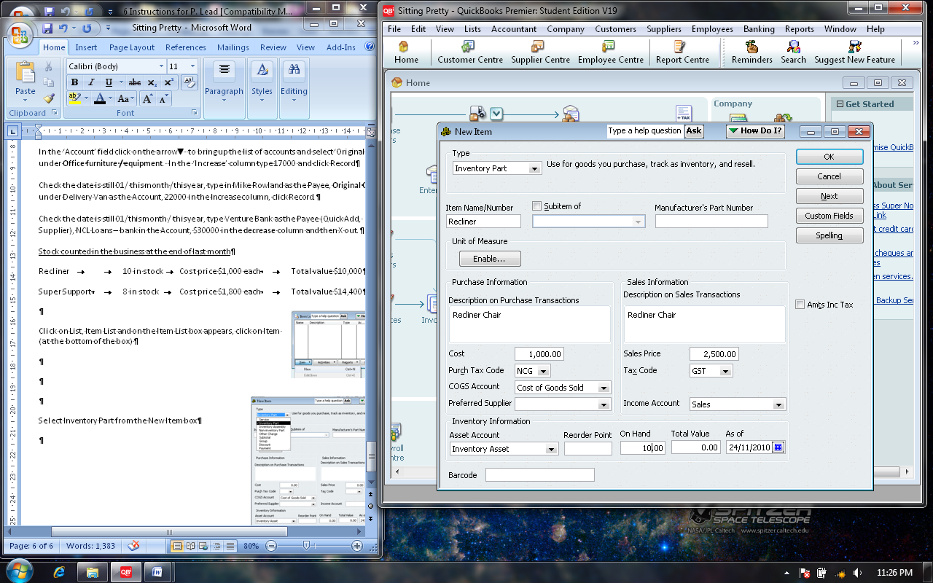

Select Inventory Part from the New Item box

Type **Recliner** in the Item Name / Number,

**Recliner Chair** in Description on Purchase Transactions,

**1000** in Cost,

**NCG** next the Purch Tax Code,

**10** under On Hand and date 01/ this month/ this year,

Type **2500** to the right of Sales price

**GST** next to Tax Code

**Sales** next to Income Account and OK

Repeat for the **Super Support** as an Inventory Part > Super Support as the Item Name/Number, Cost $1800, Purch Tax Code NCG, COGS Account should appear as Cost of Goods Sold, Sales Price $4400, Tax Code GST, Income Account Sales and OK.

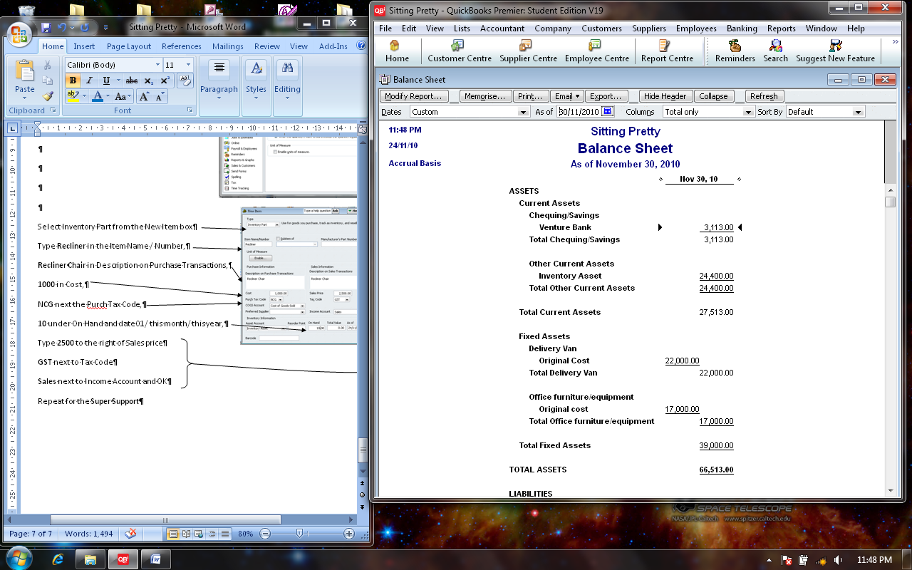**Checking the Balance Sheet**

**Venture Bank is the money in the Bank $3,113**

**Inventory Asset is the stock on hand ready to sell $24,400**

**Deliver Van $22,000**

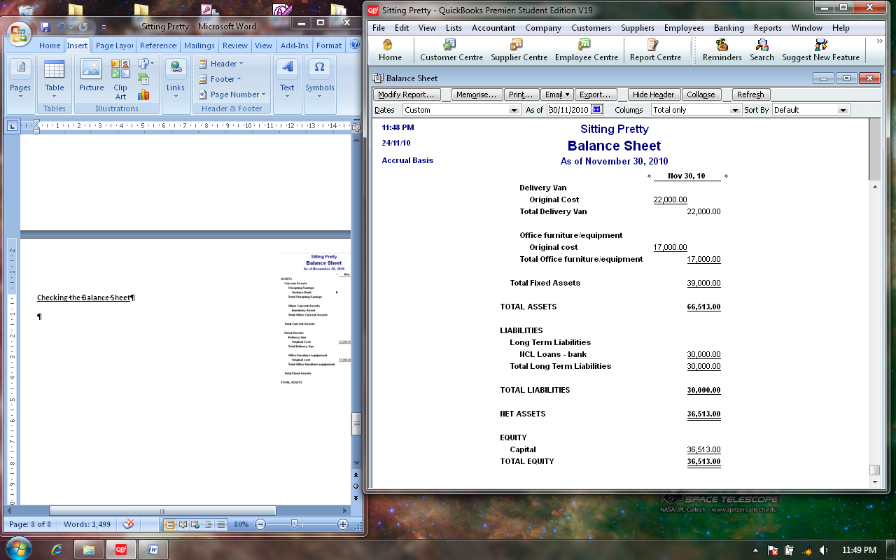**Office furniture / equipment $17,000**

**NCL Loan – bank is a Non Current Liabilities from the bank $30,000**

**Capital is the value of assets that the owner has put into the business $36,513**

**The following transactions took place during the month.**

**Date Transaction Document**

2nd November Cash Sale of 1 **Recliner** $2,500 (Plus $250 GST) Sale no 62

5th Paid Wages $800 to S. J. Hammond Chq 4135

**Drawings** of cash for own use $600 Chq 4136

6th Paid 3 months **Prepaid Rent** (Other Current Asset, NCG) $9000 (plus $900

GST) to Wyvern Real Estate. Chq 4137

7th Cash Sale of 2 **Recliners** and2 **Super Supports** $13,800 (plus

$1380 GST) Sale 63

12th Bought 3 **Recliners** and 4 **Super Supports** for cash $10200 Chq 4138

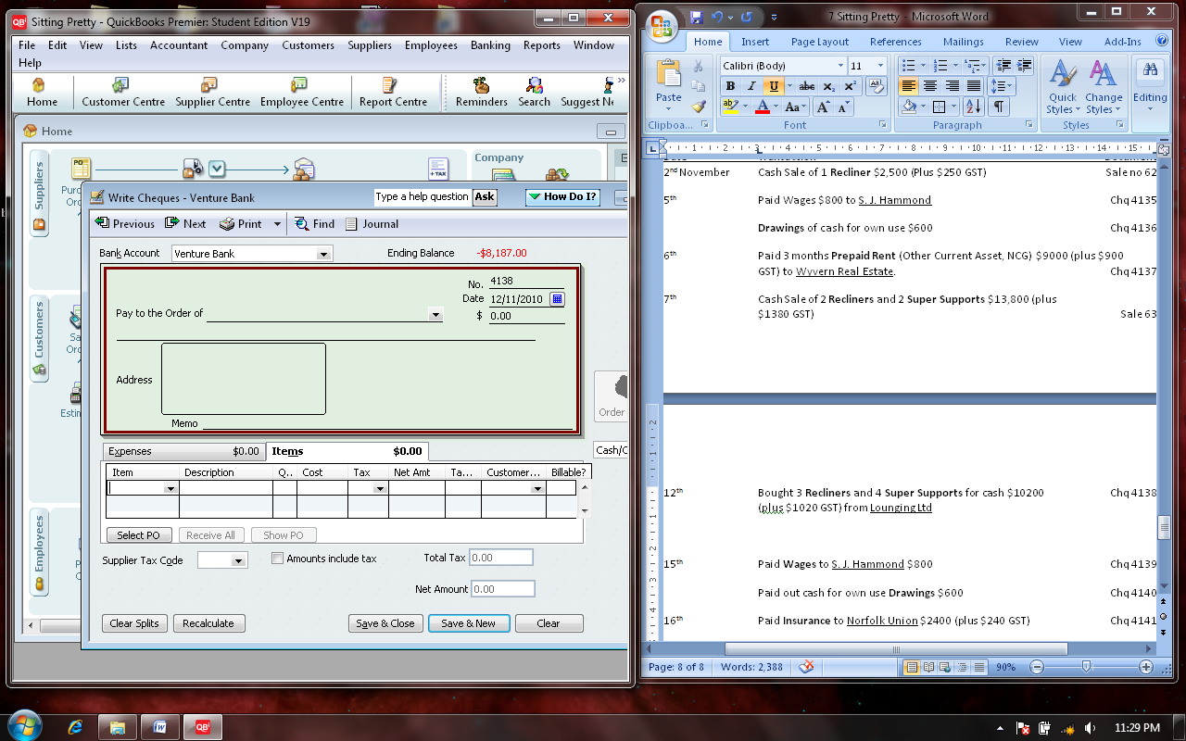 (plus $1020 GST) from Lounging Ltd

Click on Write Cheque, and enter the name of the Supplier Longing Ltd next to Pay to the Order of, date 12/11/this year and then click on the Item tab to enter the number of chairs purchased.

Save and New – Click on the Expenses Tab before you enter the next

cheque.

15th Paid **Wages** to S. J. Hammond $800 Chq 4139

Paid out cash for own use **Drawings** $600 Chq 4140

16th Paid **Insurance** to Norfolk Union $2400 (plus $240 GST) Chq 4141

18th Paid **Petrol & Oil MV 1**  to Ampol $340 (plus $34 GST) Chq 4142

20th Sale of 3 **Super Support** chairs $13200 (plus $1320 GST) Sales 64

23rd Sales of 1 **Super Support** chair $4400 (plus $440 GST) Sales 65

24th Bought 5 **Recliners** and 3 **Super Support** chairs $10400 (plus $1040 Chq 4143 GST) from Longing Ltd. (Remember to click on the Item Tab)

26th Paid **Telephone** to Telstra $420 (plus $42 GST) Chq 4144

29th Paid **Wages** to S. J. Hammond $800 Chq 4145

Paid out cash for own use **Drawings** $600 Chq 4146

30th Paid for **Repairs Expense** $750 (plus $75 GST) to Electronics Solutions Chq 4147

Sales of 8 **Recliners** and 1 **Super Support** chair $64000 (plus $6400 GST) Sales 66

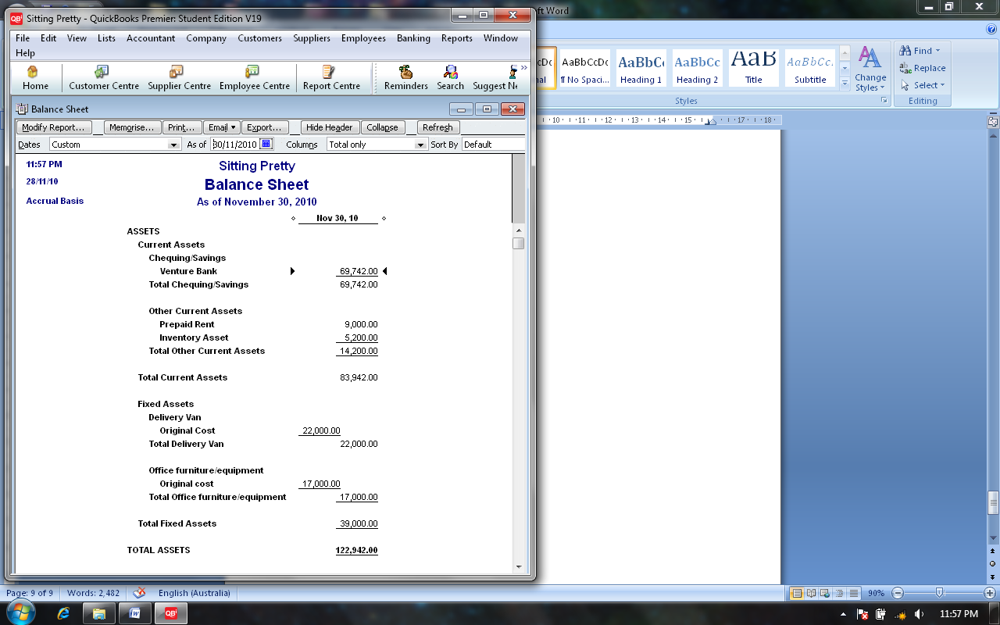Record Deposits

Prepare a Profit & Loss Statement and a Balance Sheet; they should look like the ones below. If not, go back and

* check your dates on the top of the reports
* and on each of the cheques and sales receipts.

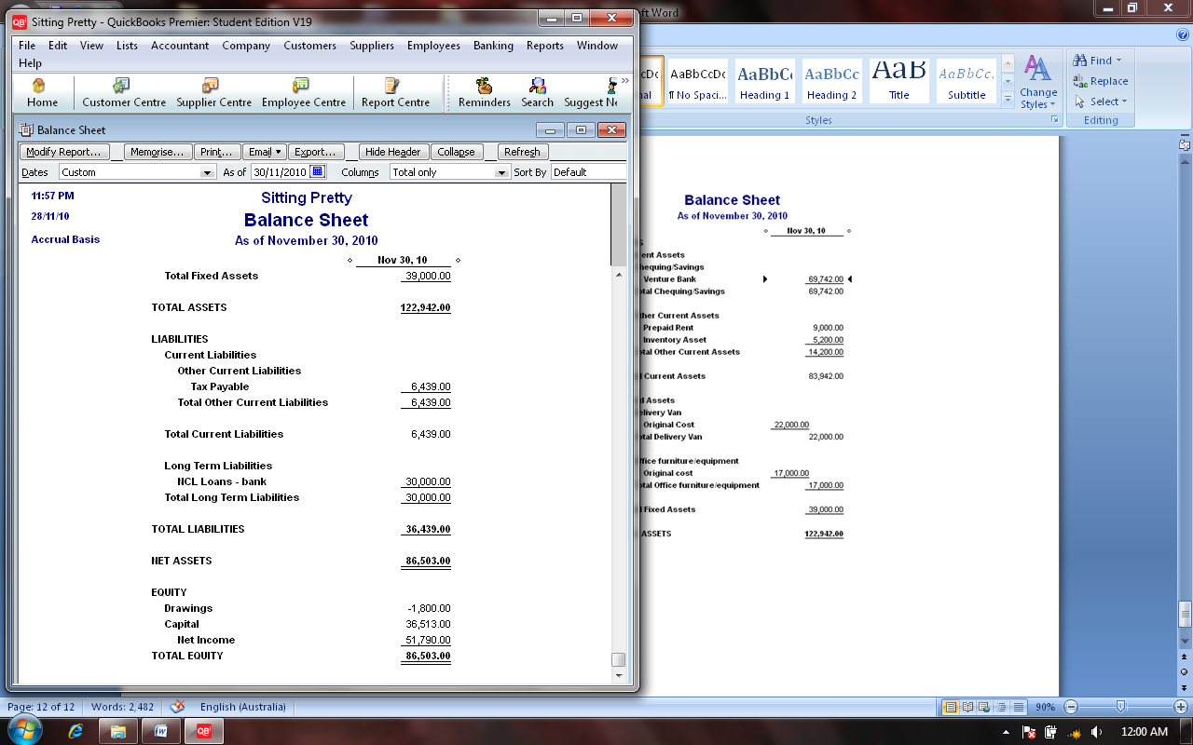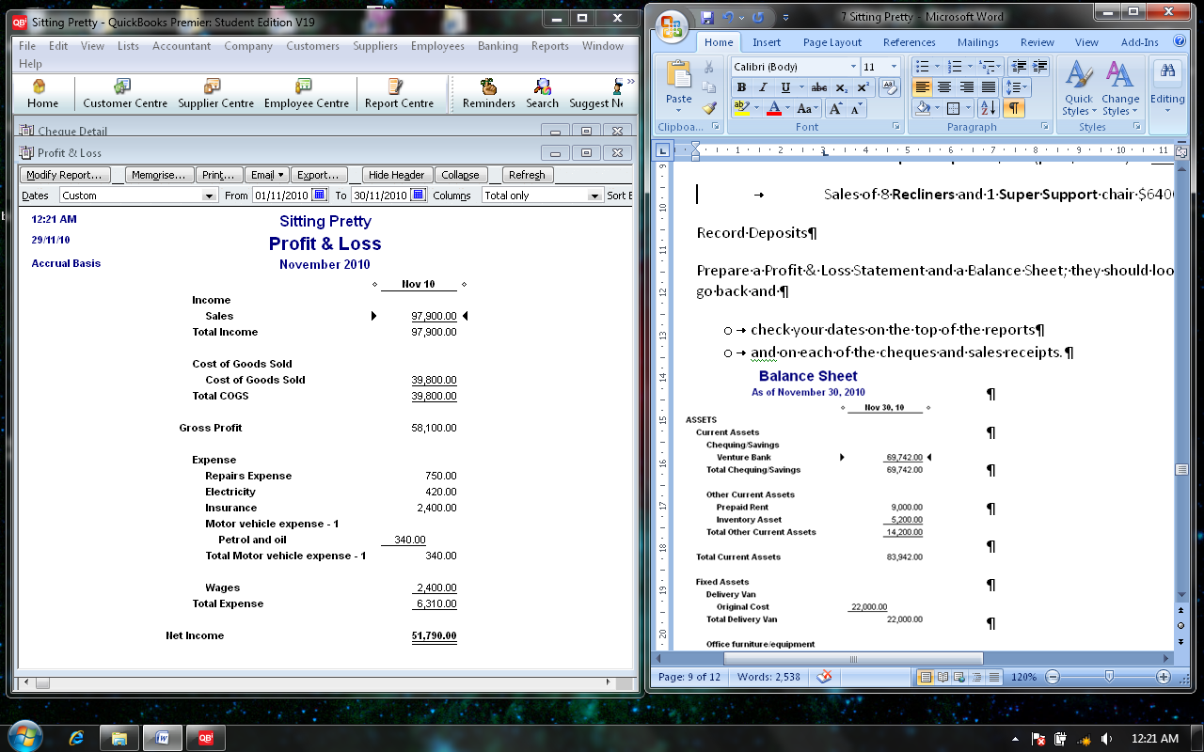

Once you have fixed as much as you can, go to Reports > Banking > Cheque Details and compare yours to the Cheque Details below.

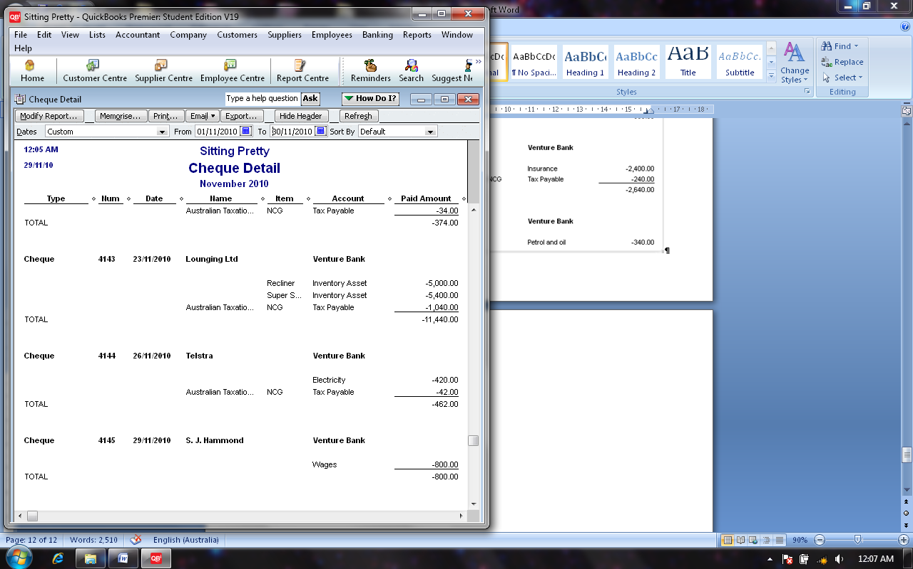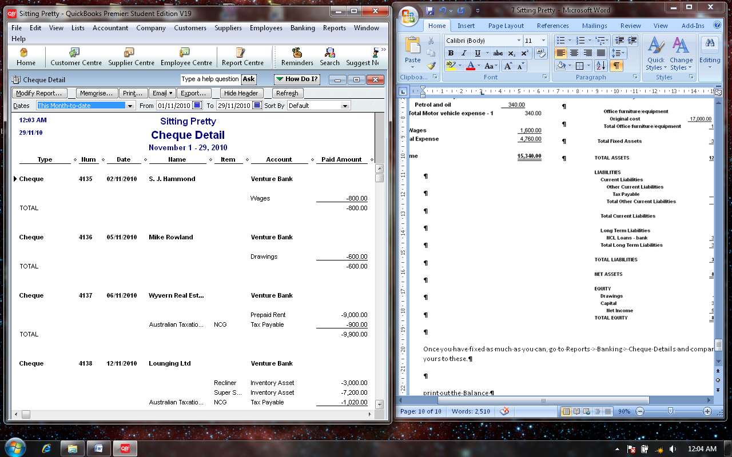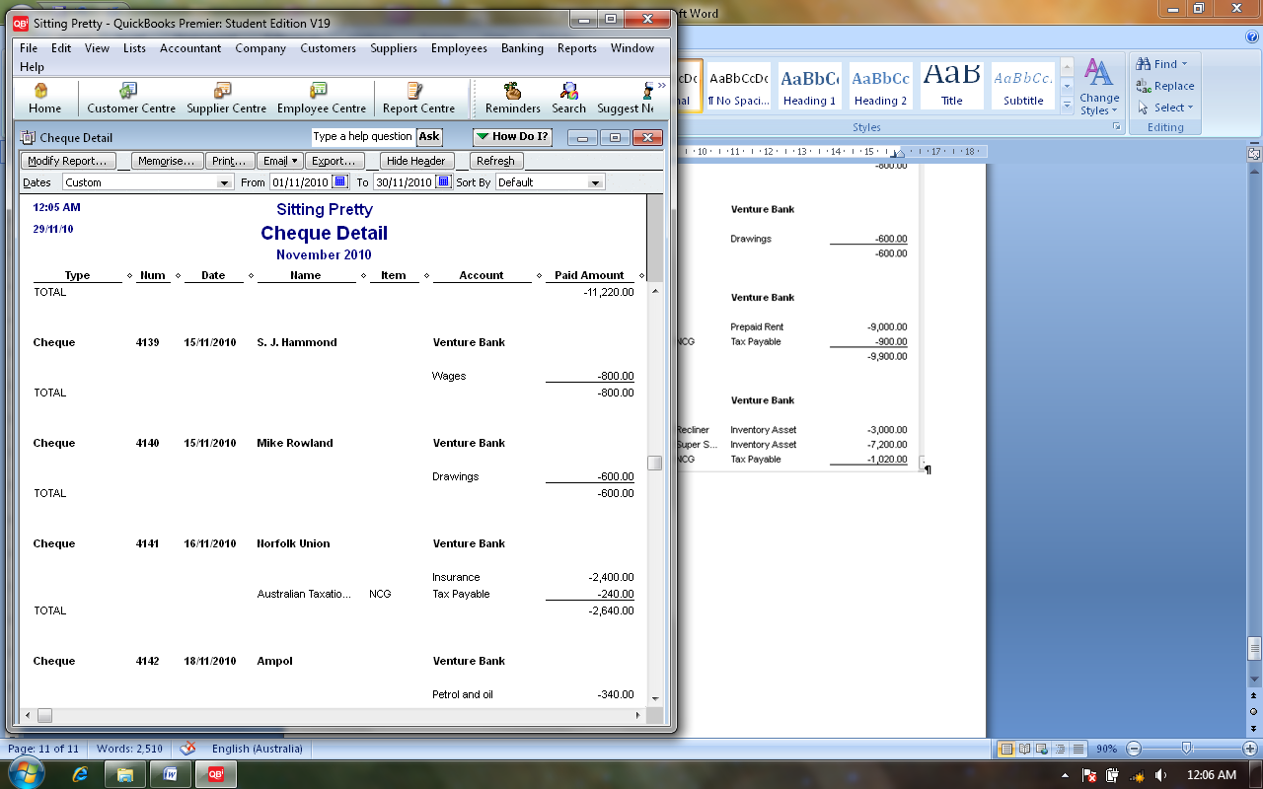



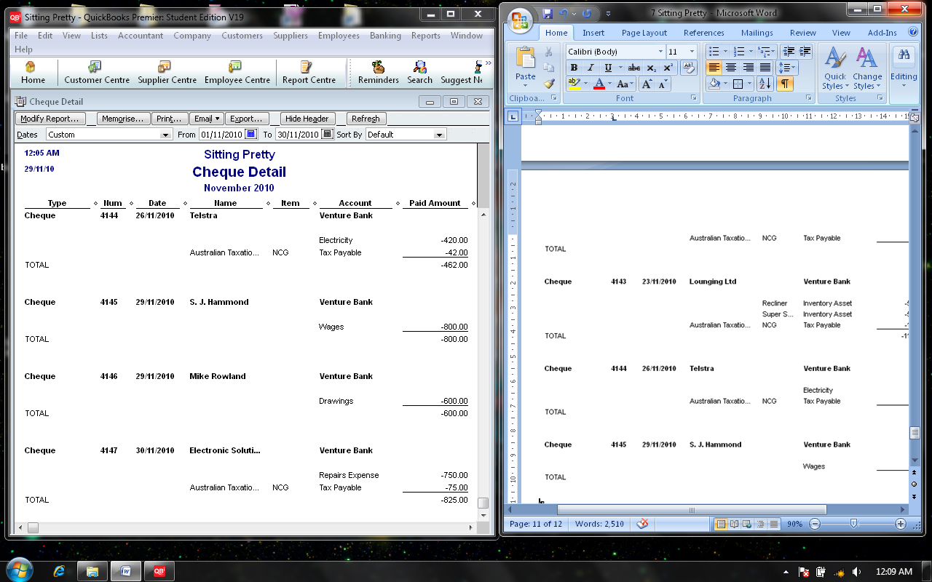

Correct any errors (change the dates on the cheques or sales receipts) and check your Balance Sheet again. If your Balance Sheet is still not correct, print out the Balance Sheet with your name on it and hand it in.